- JavaScript has distinct types for numbers like int, float, etc.
True or false
- True
- False
- How to raise 10 to the power 2?
- Math.pow(10, 2)
- 10 ** 2
- Both of the above
- None of the above
- How to round 1.65 to the nearest integer
- Math.round(1.65)
- Math.floor(1.65)
- Both of the above
- None of the above
- Math.ceil(1.0005) returns what?
- 1
- 2
- 1.5
- 1.005
- typeof NaN returns "number".
True or false?
- True
- False
- Math.random() * 100 returns a number between
- 0 and 1
- 0 and 100
- 0 and 50
- 1 and 100
- What will toPrecision(0) return when run on the number 0.56?
- 0
- “0”
- “0.5”
- It will throw an error

- What will the output include?
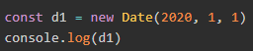
- Jan 01 2020
- Feb 01 2020
- RangeError: Invalid argument.
- What will the output include?
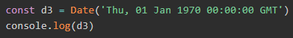
- 01 Jan 1970
- Unix Epoch of 0
- Current Date, in UTC/GMT
- Current Date
- NaN
- What will the output include?
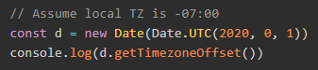
- 0
- 420
- 700
- 1400
- null

